**Technical Report: C-D side view of “Complete House Design” in AutoCAD 2018**

**Name: Md Sharif Hossain**

**ID: 1712336642**

**EEE 154: Introduction to Engineering Drawing, Section – 13**

**Group: C**

**Introduction:** In this report, the instructions and steps for sketching of a **Complete House Design** plan is shown with detailed illustrations. To sketch a Complete House Design (Side view), we started with a reference image of a Complete House Design collected from internet.

We used this reference image to generate a 2D sketch of the Complete House Design. We applied various operations to plot the Complete House Design.

On this Complete House Design project, my part was to sketch right side (C-D) view of the outside area. My reference image of the Complete House Design project is showed below: (Fig 0.1)

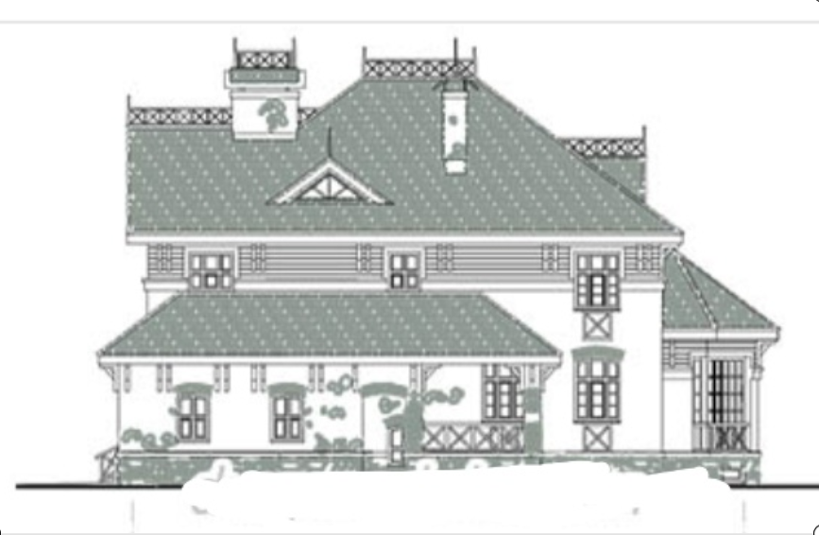

**Figure 0.1:** Reference image of right side (C-D) view

**Step 1: Inserting reference image**

I used top view of 2D wireframe on Drafting & Annotation workspace to sketch the design. First, I copied the reference image using “copy” option (Fig 1.1) and pasted it in workspace using “Ctrl + V” (Fig 1.2). While Pasting, image size and angle were needed to be declared. I used a random size (Fig 1.3) and angle of 0 degree (Fig 1.4). Once the image was copied successfully in the workspace, I found the following view: (Fig 1.5)

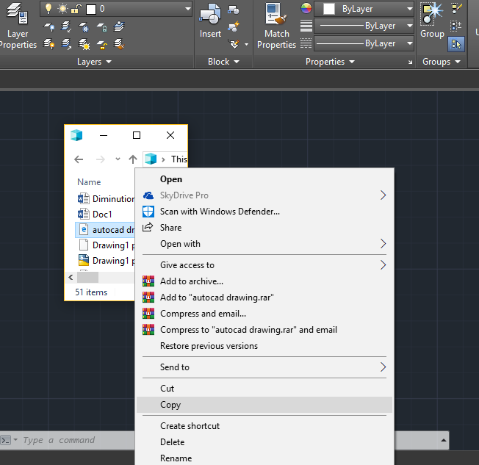

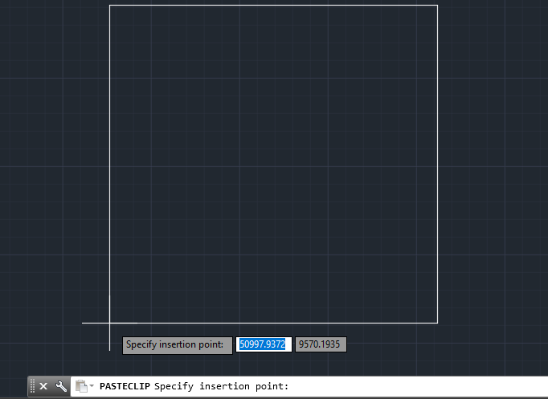

**Figure 1.1:** Copying Image **Figure 1.2:** Pressed “Ctrl + v”

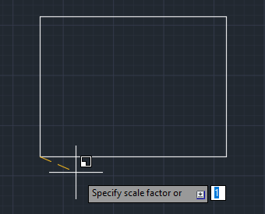

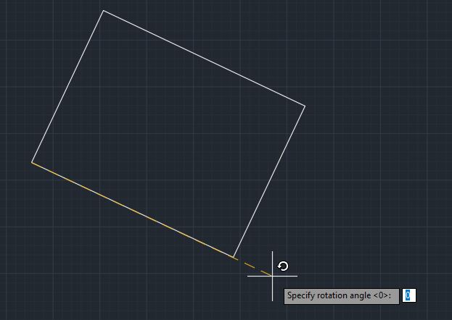

**Figure 1.3:** Scaling **Figure 1.4:** Angle position

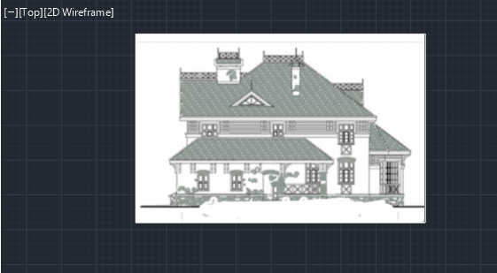

**Figure 1.5:** Image was copied in workspace

**Step 2: Defining Layers**

There were 6 Layers used: 0, Axis, Construction, Hatch, Text & Wall. (Fig 2)

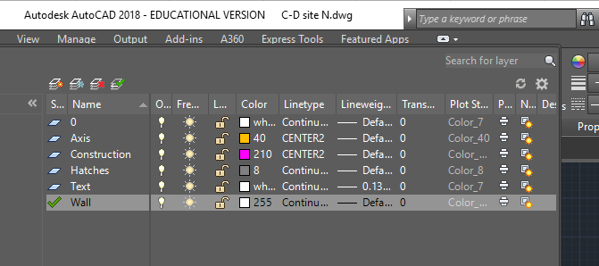

**Figure 2:** Defined layers

**Step 3: Plotting Scales**

A unique scale was used by every member to maintain the same size. (Fig 3)

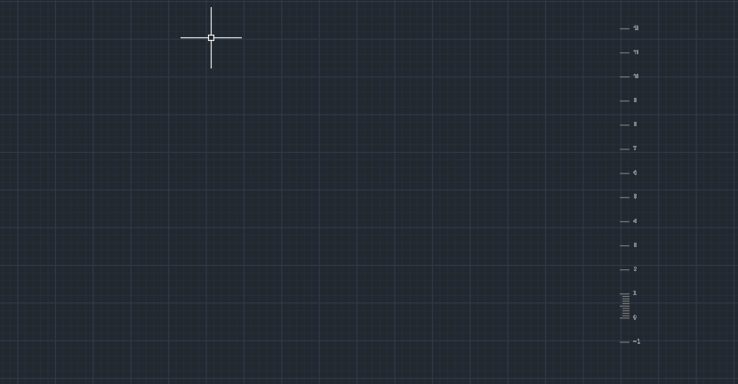

**Figure 3:** Drawing scale

**Step 4: Sketching**

I used tracing over the reference image using polylines (Fig 4.1). Firstly, I sketched the initial view of ground floor (Fig 4.2) and then modified the total basic shape (Fig 4.3). Then I added balcony, side door and windows in the sketch (Fig 4.4). After that I added the out view of fireplace and roof window (Fig 4.5). I also added rooftop design according to the reference image (Fig 4.6). I added a side balcony (Fig 4.7) and some extra designs which gave the final view before hatching (Fig 4.8).

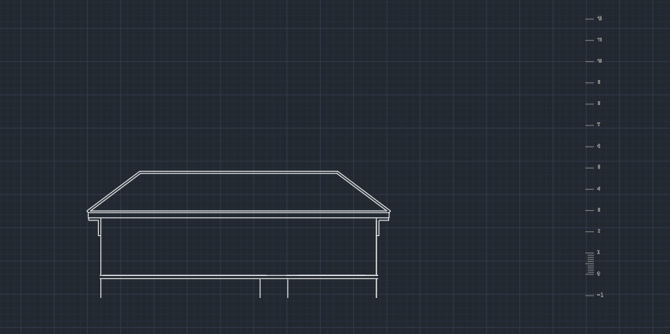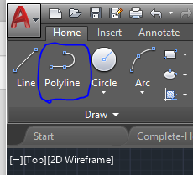

**Figure 4.1:** Selecting polyline **Figure 4.2:** Initial shape

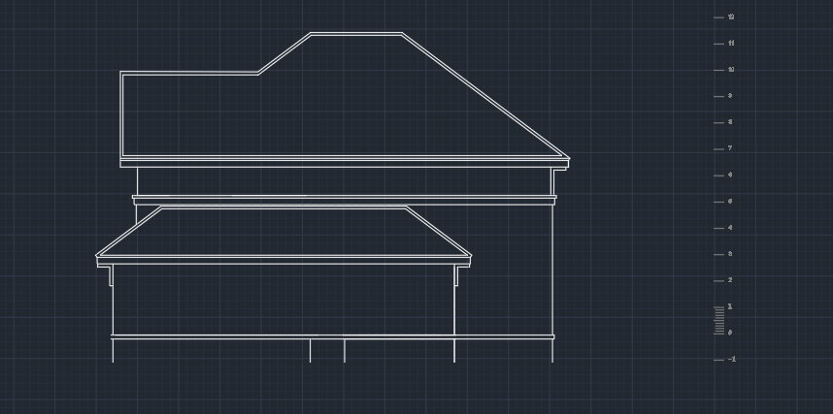

**Figure 4.3:** Total basic shape

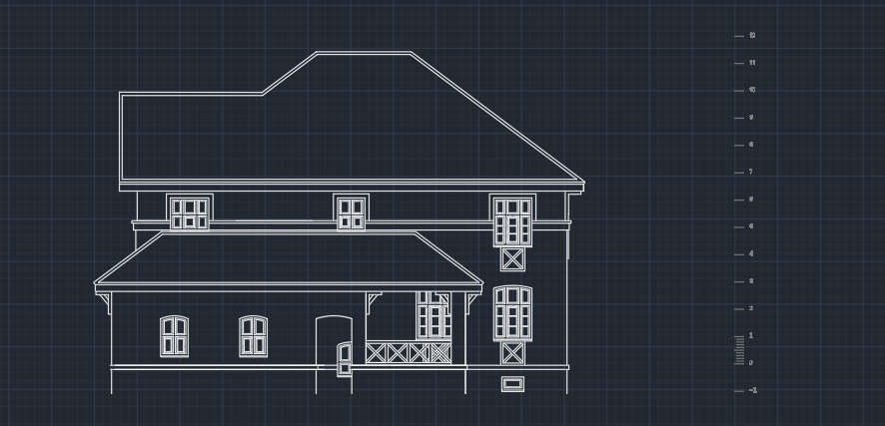

**Figure 4.4:** Added balcony, side door & windows

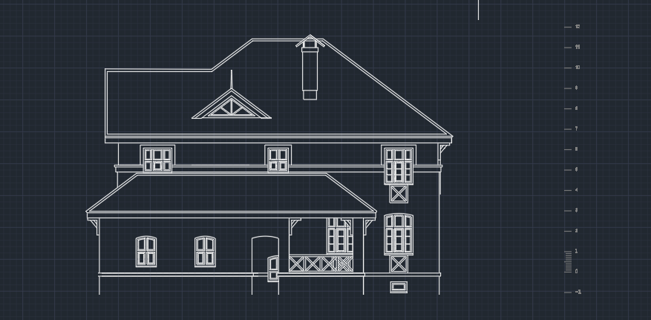

**Figure 4.5:** Added fireplace and roof window

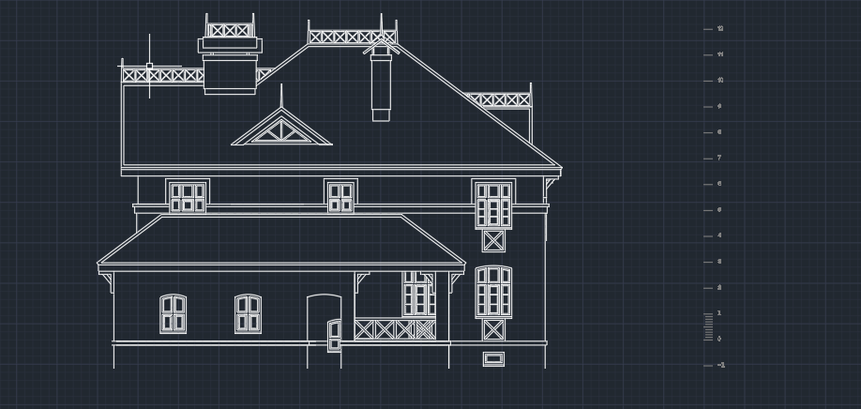

**Figure 4.6:** Added rooftop design

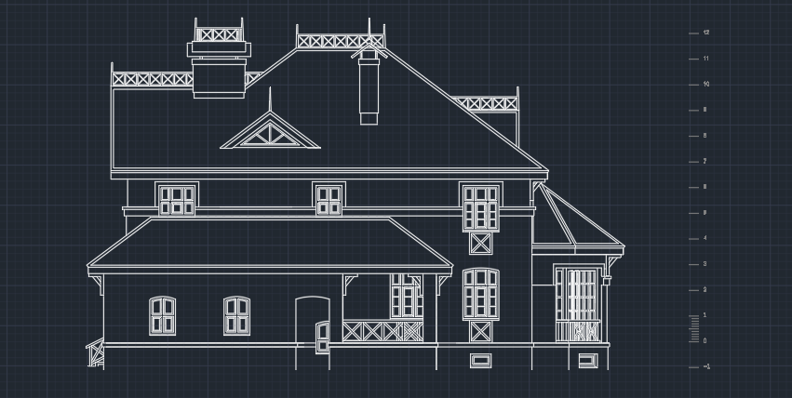

**Figure 4.7:** Added side balcony

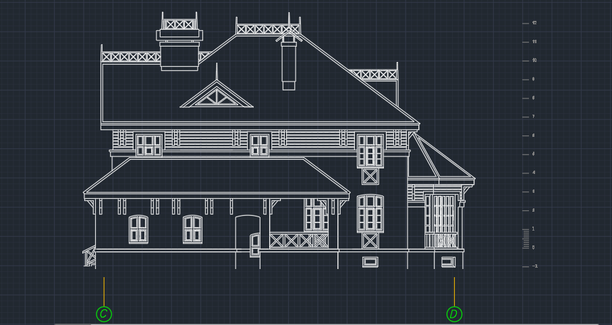

**Figure 4.8:** Semi-Final View (Before hatching)

**Step 5: Hatching**

Once all of the group members had completed their sketches, I put them in a single workspace and drew same hatch in all of the views. The final view after hatching is following: (Fig: 5)

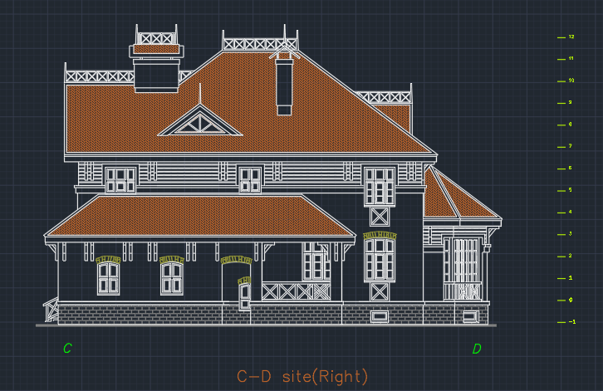

**Figure 5:** Final View